SHOPEZ – FULL STACK MERN E-COMMERCE PLATFORM
1. INTRODUCTION
Project Title:
ShopEZ – Full Stack MERN E-Commerce Platform
Team Member:
Sama Mahith Reddy
Role:
Full Stack Developer
2. PROJECT OVERVIEW
Purpose:
ShopEZ is a full-stack e-commerce web application developed using the MERN stack. The system allows users to browse products, register accounts, log in securely, add products to cart, place orders, and manage purchases through a user friendly interface.
Features:
• User Registration and Login
• Product Browsing by Categories
• Product Search Functionality
• Shopping Cart Management
• Checkout System
• Responsive User Interface
• Admin User Support
• Product Management
• MongoDB Database Integration
3. ARCHITECTURE
Frontend:
The frontend is developed using React.js and Vite. It provides an interactive and responsive user interface for customers to browse products and manage their shopping experience.
Backend:
The backend is developed using Node.js and Express.js. REST APIs are used for communication between frontend and backend.
Database:
MongoDB is used to store user information, product details, orders, and authentication data.

React Frontend
↓
Express.js API
↓
Node.js Server
↓
MongoDB Database
4. SETUP INSTRUCTIONS
Prerequisites:
• Node.js
• npm
• MongoDB Community Server
• MongoDB Compass
• VS Code
Installation Steps:
1.Download the ShopEZ project.
2.Open terminal inside project folder.
3.Install backend dependencies:
npm install
4.Install frontend dependencies:
cd client
npm install
5.Configure .env file.
6.Start backend:
cd server
node index.js
7.Start frontend:
cd client
npm run dev
5. FOLDER STRUCTURE
Client:
• components
• pages
• assets
• App.jsx
• index.css
Server:
• config
• controllers
• middleware
• models
• routes
• index.js
6.RUNNING THE APPLICATION
Backend:
cd server
node index.js
Frontend:
cd client
npm run dev
Application URL:
http://localhost:5173
7. API DOCUMENTATION
Authentication APIs:
• POST /api/auth/register
• POST /api/auth/login
Product APIs:
• GET /api/products
• GET /api/products/:id
Cart APIs:
• POST /api/cart
• GET /api/cart
Order APIs:
• POST /api/orders
• GET /api/orders
Admin APIs:
• GET /api/admin/products
• GET /api/admin/orders
8. AUTHENTICATION
Authentication is implemented using JSON Web Tokens (JWT).
Features:
• User Registration
• User Login
• Token Generation
• Protected Routes
• Role-based Access Control
9. USER INTERFACE
The user interface includes:
• Home Page
• Category Section
• Product Listing Page
• Product Details Page
• Shopping Cart
• Login Page
• Registration Page
• Checkout Page
• Admin Dashboard
10. TESTING
Testing Performed:
• User Registration Testing
• User Login Testing
• Product Search Testing
• Cart Functionality Testing
• Checkout Testing
• Admin Functionality Testing
• API Endpoint Testing
- SCREENSHOTS OR DEMO
Demo URL:
http://localhost:5173
Screenshots Included:

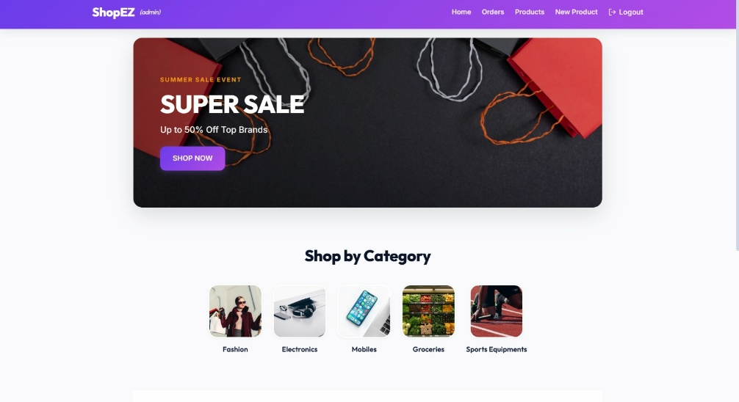

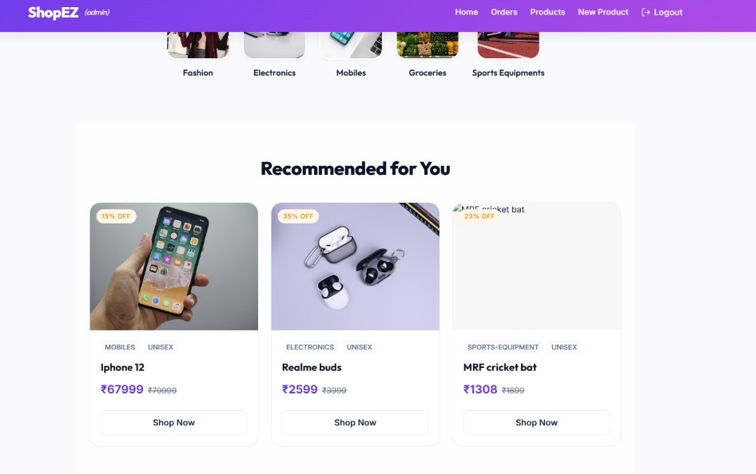
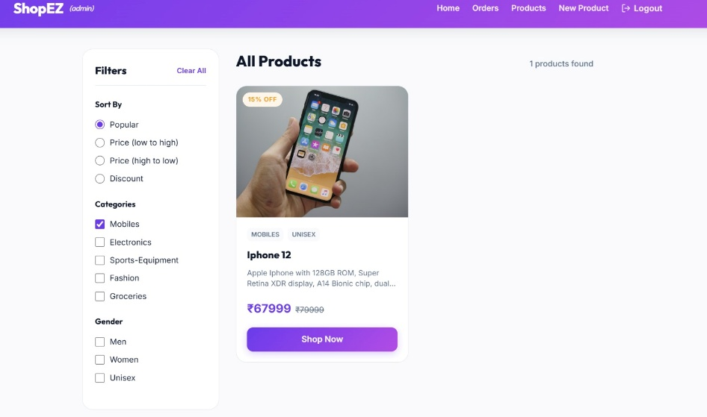
- KNOWN ISSUES
• MongoDB must be running for persistent data storage.
• Some external image URLs may occasionally fail.
• Mock Database Mode resets data after server restart.
- FUTURE ENHANCEMENTS
• Online Payment Gateway Integration
• Wishlist Functionality
• Product Reviews and Ratings
• Order Tracking System
• Email Notifications
• Cloud Deployment
• Mobile Application Version
• AI-Based Product Recommendations

